

Cairo University

Faculty of Computers and Information Department of Software Engineering

Health Care

Sensing & Monitoring

# Supervised by

*Dr. Hanaa Bayoumi TA. Sarah Hassan*

# Implemented by

|  |  |
| --- | --- |
| *20175009* | *Abdelrahman Gamal Hussien* |
| *20176019* | *Fatma Hesham Ahmed* |
| *20176036* | *Omar Aly Gamal El-Din Mahran* |
| *20176016* | *Aly Hesham Zahra* |
| *20175011* | *Omar Mohamed Abdallah* |

## Graduation Project Academic Year 2020-2021

Midyear Short Documentation

|  |  |
| --- | --- |
|  | Cairo University  Faculty of Computer and Artificial Intelligence  Department of Computer Science |

1. **Document Content**
2. ***Abstract:***

* ***Existing Problems:***
  + *Reducing the spread of infectious (specially corona virus) diseases.*
  + *Difficulty to find and book the right provider (healthcare accessibility).*
  + *Weak medical records usage and lack of health information.*
  + *Weakly informed and engaged patients on disease management and medical prescriptions.*
  + *Wasting time waiting for doctors.*
* ***Motivation to Solve It:***
* *Our Motivation is to reduce the crowdedness of clinics and hospitals due to the pandemic (covid-19), by helping patients with remote consultation to reduce the risk of infection.*
* *Online consultation was the best way to save your time. We aim to save all your data: medical history of illness and all medical tests that you do regularly.*
* ***Tools:***

|  |  |  |  |  |
| --- | --- | --- | --- | --- |
| 1. *Html 5* | 1. *CSS* | 1. *Bootstrap* | 1. *JavaScript* | |
| 1. *React as a Front end framework* | 1. *Animation Libraries* | 1. *Redux* | 1. *Node Js* | 1. *APIs* |

* + - *We also use GitHub as a control management system. All non-functional requirements are achieved through these tools.*

1. ***Background:***
   * *We provide a platform for the health care sector (doctors and patients), in order to interact easily, so patients can search, reserve consultation (online and offline) and compare between doctors.*
   * *According to the pandemic everything goes online specially to decrease your risk of catching Infections this is mainly what motivates us to make this project also, to save our time and all the patients data to be accessed at any time.*
   * *The beneficiary of our project is to provide an easy solution for remote consultation through a video call or some sensors also, a quick consultation using the Chat-bot and organizing patient’s and doctor’s appointments schedule.*
   * *Our techniques are: web animations, CSS media queries.*
   * *Stakeholders: patients, doctors and suppliers (Arduino).*
2. ***Problem Definition:***
   * *According to the pandemic we all fear the spread of infectious diseases so, we put a solution turning the appointment online, you will be able to have a medical report that contains all your health information and it will be updated regularly, you will be able to follow up with your doctor. And for coronavirus patients you will be able to check yourself some sensors.*
   * *Also, we all face a problem during searching for a good doctor, we will help you in choosing the appropriate doctor and the suitable appointment available (Online or offline). we also aim to save all your data and medical history to be accessed easily and it is updated regularly.*
   * *You will be able to evaluate the waiting period in the clinic so that the other patients can book the doctors with less waiting time.*
3. ***Related work:***

* ***Main Differences:***

|  |  |  |
| --- | --- | --- |
| ***Key Points*** | ***Vezeeta*** | ***Our Project*** |
| *Sensors* | ✘ | ✔ |
| *Medical History* | ✘ | ✔ |
| *Generated Report* | ✘ | ✔ |
| *Chat-bot* | ✘ | ✔ |

1. ***Project Specification:***

* 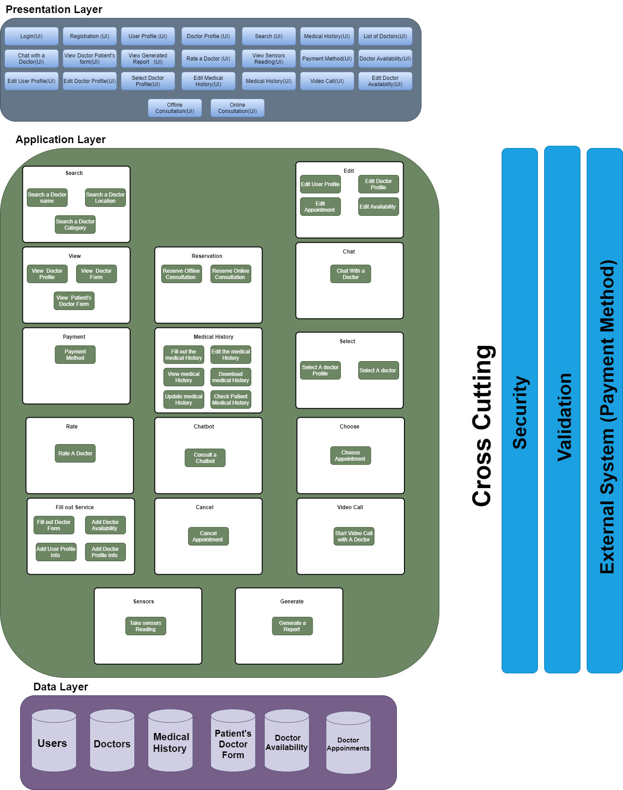***System Architecture:***
* ***Stakeholders:***
  + ***Internal:***
    - *Patients.*
    - *Doctors.*
  + ***External:***
    - *Suppliers (Arduino).*
* ***Functional Requirements:***

|  |  |
| --- | --- |
| ***PATIENT*** | ***DOCTOR*** |
| *Patient should be able to register and login.* | *Doctor should be able to register and login.* |
| *Patient should be able to search using doctor name or by Specific specialty or according to specific location.* | *Doctor will be able to have a list of his patients.* |
| *Patient should be able to edit his/her profile.* | *Doctor should be able to edit his/her profile.* |
| *Patient should be able to consult our chat bot.* | *Doctor will be able to check the sensor’s reading.* |
| *Patient should be able to fill out or edit the medical history.* | *Doctor should be able to update patient’ medical history.* |
| *Patient should be able to select a doctor and choose online or offline consultation.* | *Doctor should be notified by the appointments and their types.* |
| *Patient should be able to cancel or edit an appointment.* | *Doctor should be able to cancel or edit an appointment.* |
| *Patient should be able to have a video call (Chat) with the selected doctor online.* | *Doctor will be able to write a report with the patient’s status.* |
| *Patient should be able to fill a form before entering the video call to describe the symptoms (initial diagnosis).* | *Doctor will be able to check the form before the consultation.* |
| *Patient should be able to pay the fees of online consultation.* |  |
| *Patient should be able to rate the doctor after consultation.* | *Doctor will have these ratings on their profile.* |
| *Patient should be able to choose a specific appointment with the selected doctor.* | *Doctor should be able to add or edit the available times.* |
| *Patient should be able to view doctor profile or view his/her own medical history.* | *Doctor should be able to view patient’s online form or view patient’s sensor reading.* |
| *Patient should be able to download his/her medical history.* | *Doctor should be able to check patient’s medical history.* |

* + ***Nonfunctional Requirements:***
    - *Based on trade off analysis method (ATAM):*

|  |  |
| --- | --- |
| ***Quality attributes*** | ***Measured by*** |
| ***Performance:***  *performance here is high as it’s deployed on several machines (tiered architecture) and we will increase the performance of each tier separately.* | *Response time at most in 5 seconds.*  *The system provides acknowledgment in just one second once the patient's information is checked , Regarding user interface it will be within 5 seconds.* |
| ***Usability:***  *Doesn’t require any type of trainings in order to use it.* | *Normal operations are easy to be used*  *Error messages are understandable* |
| ***Scalability:***  *- Scale out*  *-Scale up* | *It may support 1000 user once.* |
| ***Security:***  *Data is encrypted* | *Patient Identification: The system needs the patient to enter a personal proof using valid mail or phone number.*  *Doctor identification: The system needs the doctor to enter a personal proof himself using valid mail or phone number and a Business Card photo.*  *Login ID: Any user who will use the system need a Login ID and password.*  *data encryption: personal information like password and MasterCard number are encrypted in database, all transactions should be encrypted.* |
| ***Availability:***  *Availability will be achieved through a queue which will handle all the user requests it will be placed inside each controller.* | *System will be available all the time*  *No data loss at anytime* |
| ***Testability:***  *It’s easily achieved here as we separate the application into layers also the application layer is divided into services so it can be tested easily.* | *Testing each component is easily* |
| ***Modifiability:***  *Loosely Coupled by applying SOLID principles and design patterns.* | *Modifying each component is easily* |
| ***Maintainability:***  *Back-Up: The system offers the efficiency for data backup.* | *system elements can be repaired in a defined environment within a short period of time* |

* + 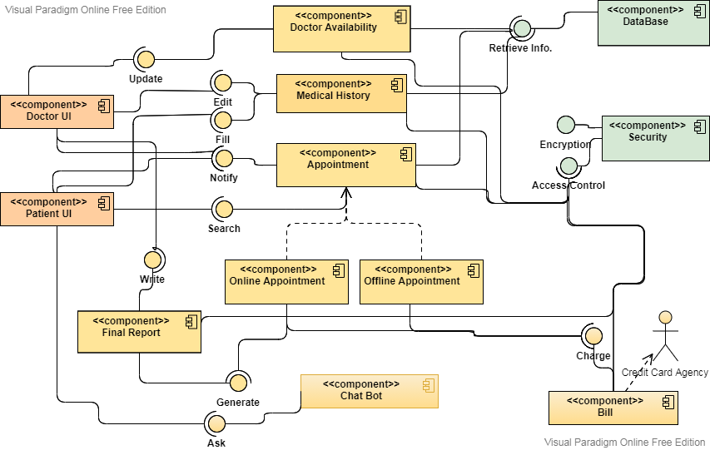***Component Diagram:***
  + 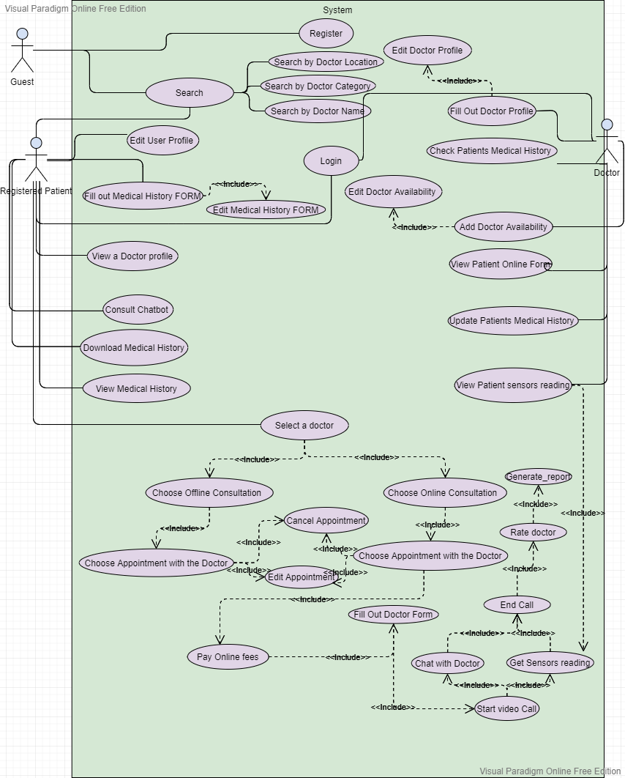***Use-case Diagram:***
  + 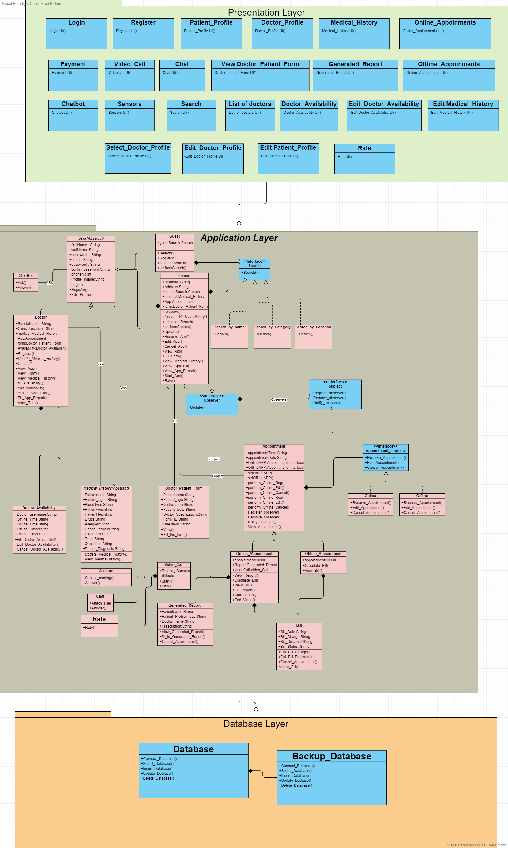***Class Diagram:***
  + ***Sequence Diagram:***
    - ***Patient Side:***
      * ***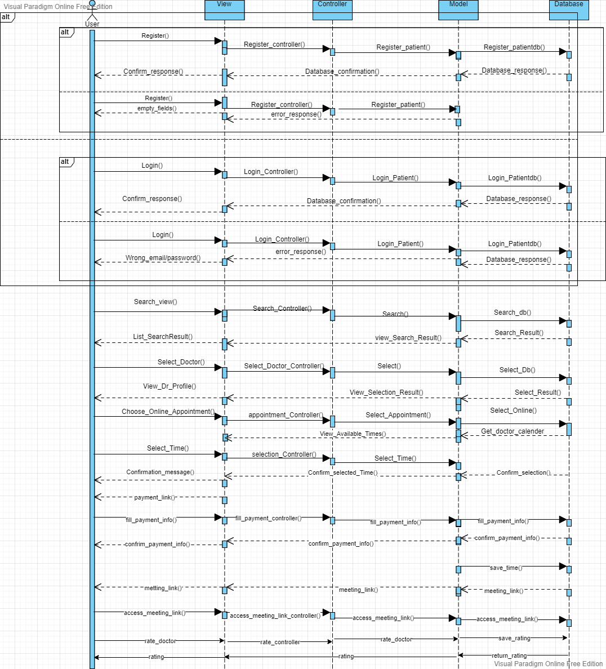****Online reservation:*
      * ***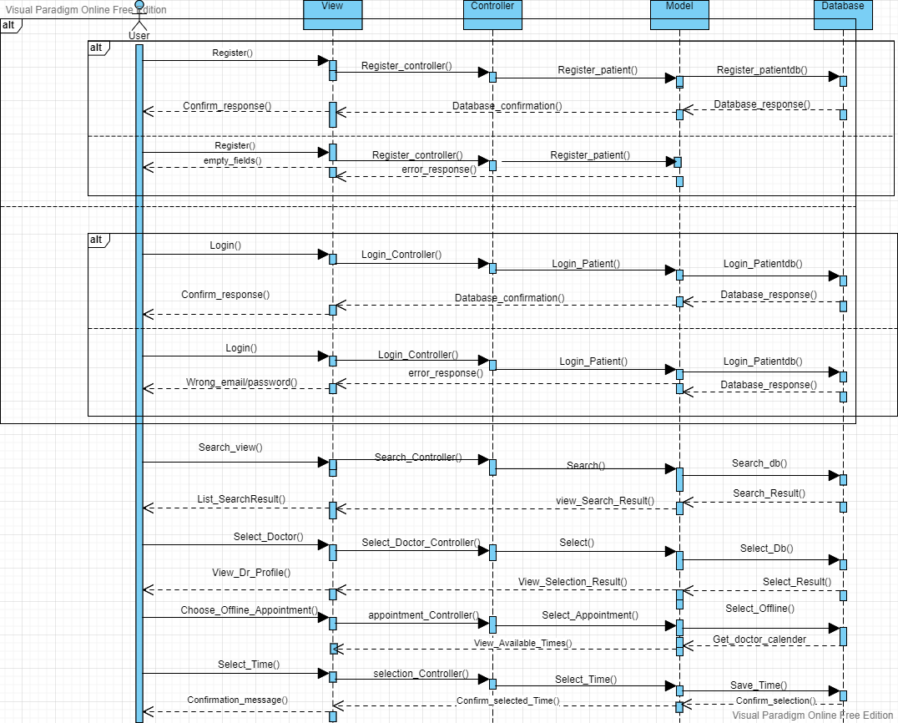****Offline reservation:*
    - ***Doctor Side:***
      * ***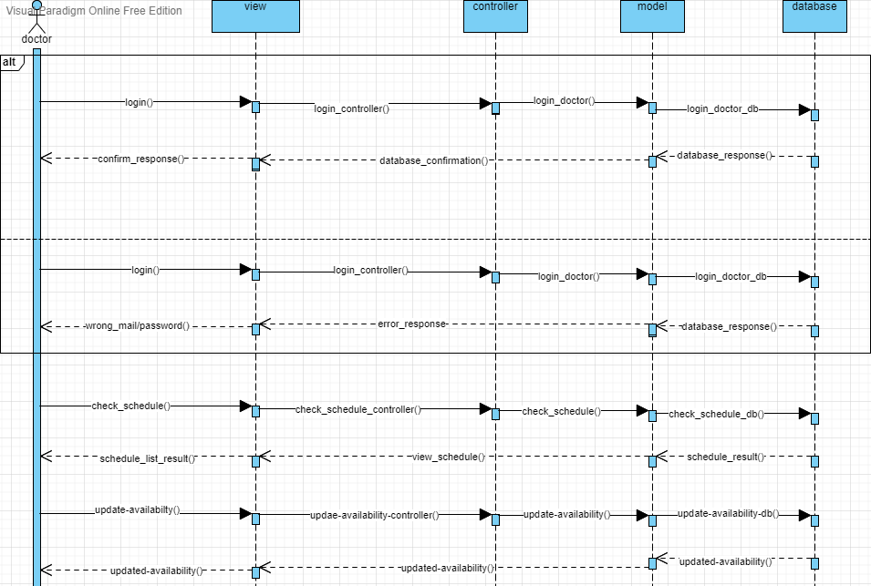****Doctor Availability:*
      * ***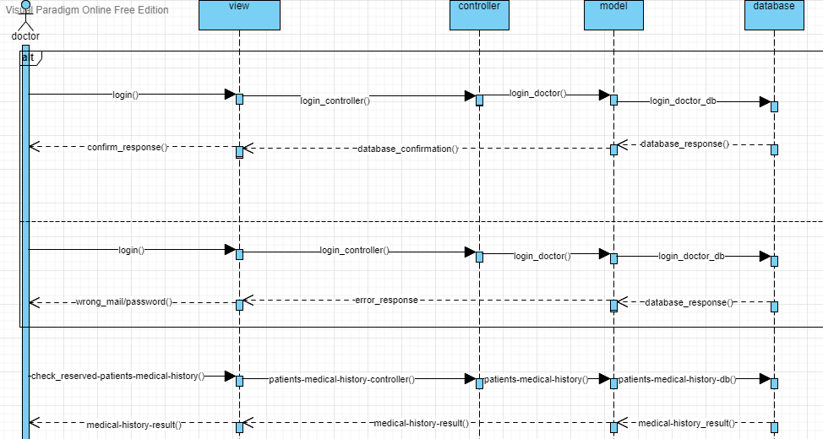****Update Medical History:*
  + ***Entity Relationship Diagram (ERD):***
* 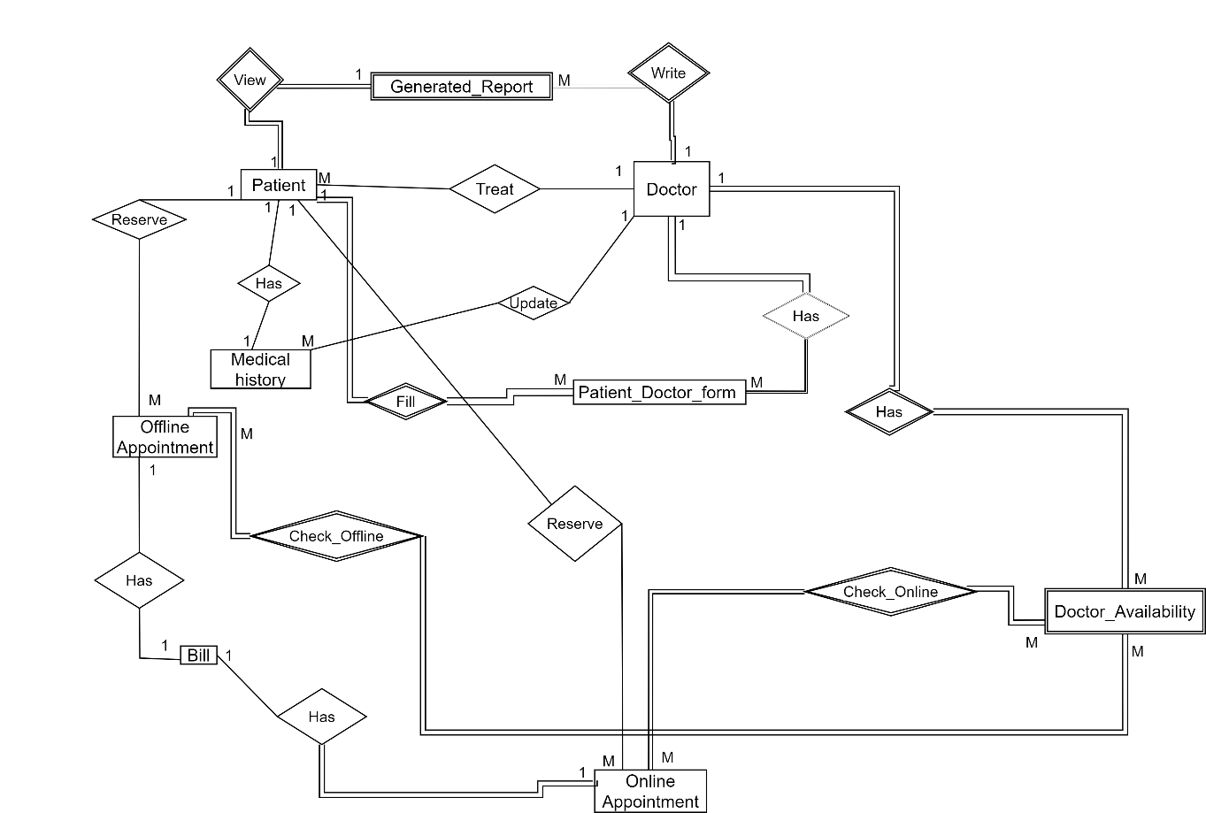*Relationship between Entities:*
  + - *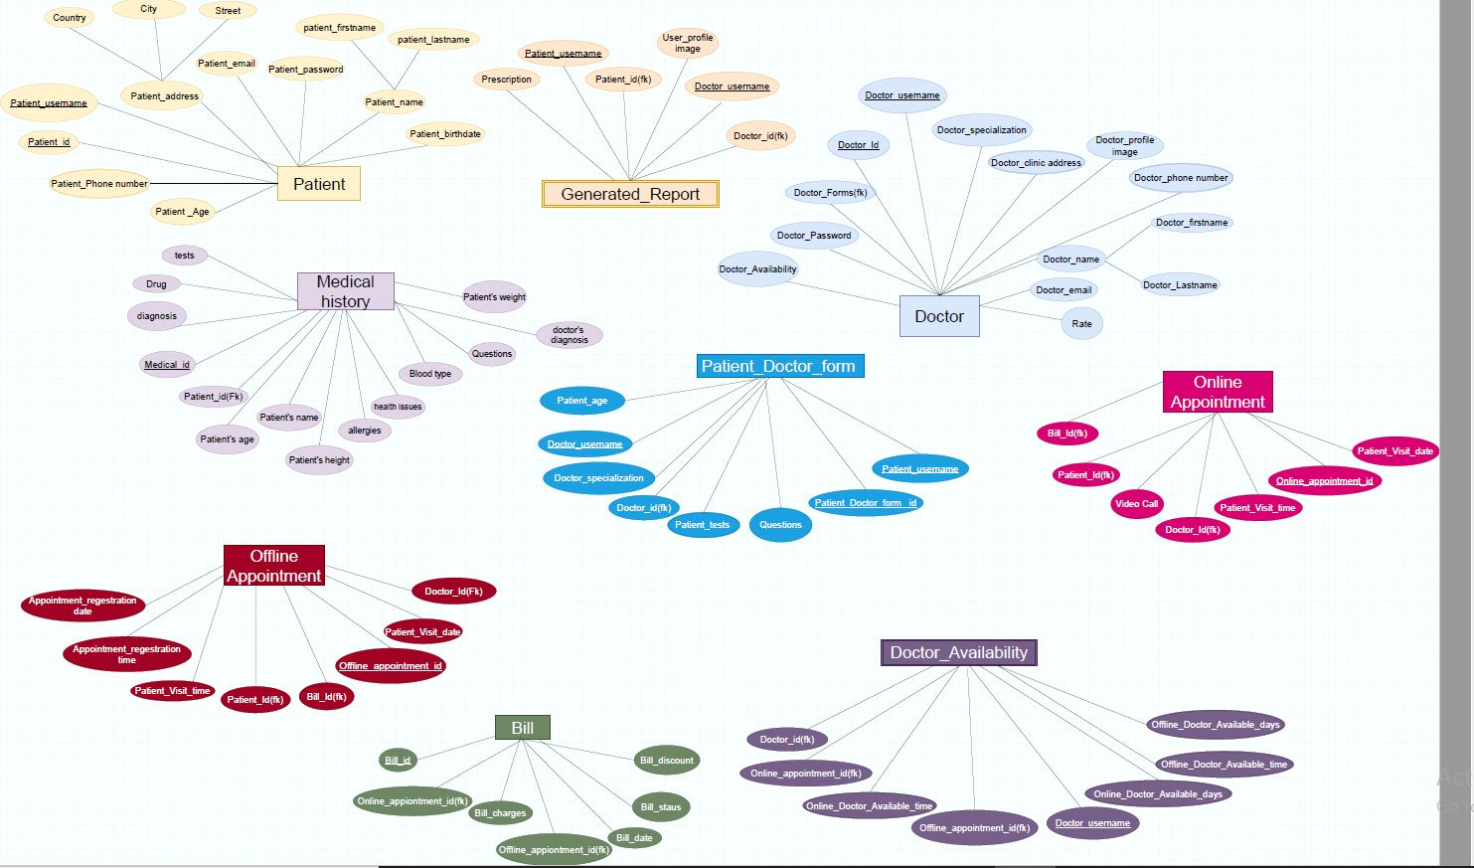Entities with Attributes:*
  + ***Activity Diagram:***
    - ***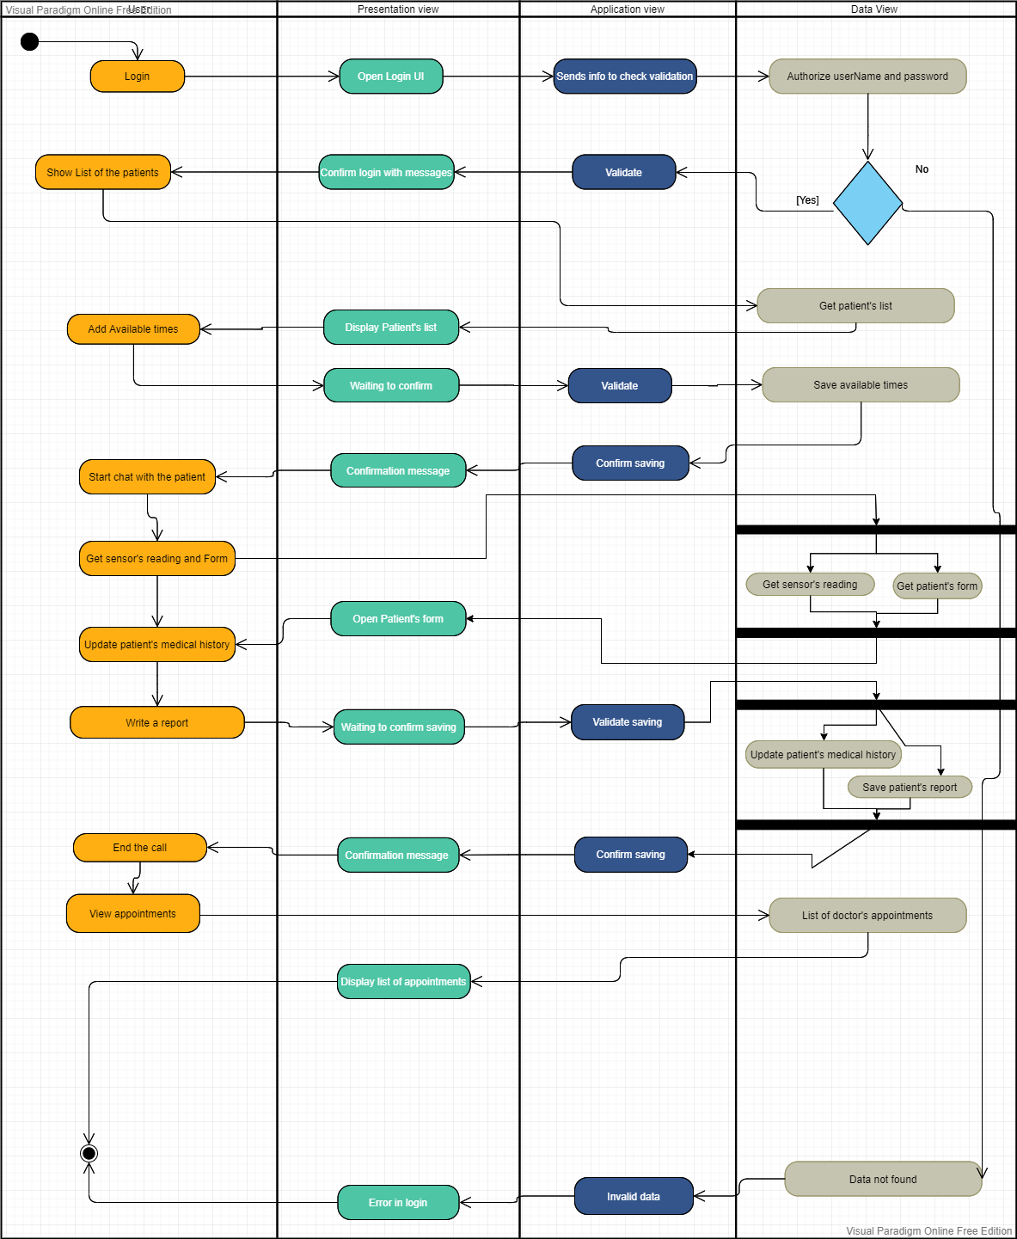****Doctors Side:*
    - *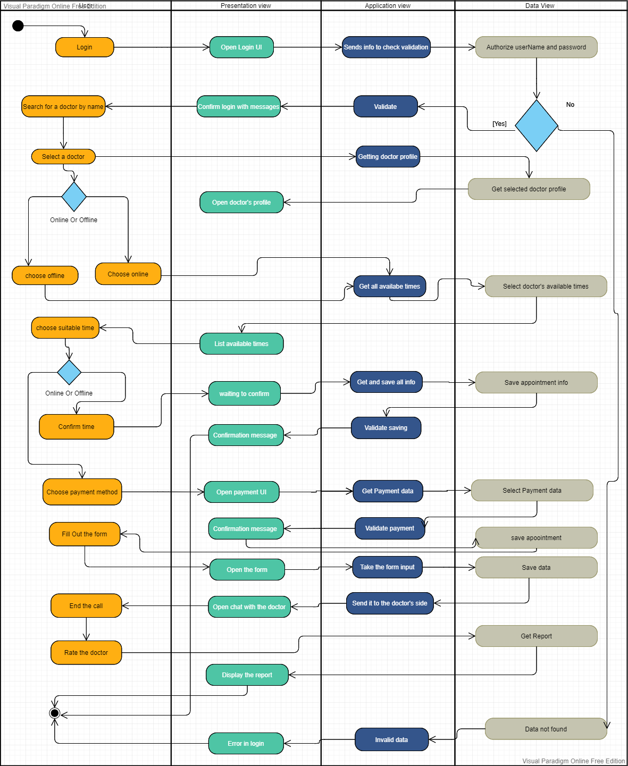Patients Side:*

1. ***Work Plan:***

|  |  |  |  |
| --- | --- | --- | --- |
| *Task* | *Task title* | *Task description* | *Task status* |
| *1* | *Brain-Storming* | *Generating ideas for Graduation Project.* | *Completed* |
| *2* | *Gathering Data* | *Gather information about specific idea.* | *Completed* |
| *3* | *Problem Definition* | *Identifying the problem and formulating questions for the idea.* | *Completed* |
| *4* | *Generating Solutions* | *Generating possible solutions using various tools.* | *Completed* |
| *5* | *Selecting best solution* | *Choosing the best solution.* | *Completed* |
| *6* | *Defining Requirements* | *Done through Software Requirements Specification.* | *Completed* |
| *7* | *Survey* | *Taking people’s opinions into consideration* | *Completed* |
| *8* | *Functional Requirements* | *Stating main features of the project.* | *Completed* |
| *9* | *Non-Functional Requirements* | *Describing the systems operation capabilities and constraints.* | *Completed* |
| *10* | *Software Architecture* | *Choosing the appropriate style, then designing it.* | *Completed* |
| *11* | *Use-case Diagram* | *Representing the user’s interaction with the system.* | *Completed* |
| *12* | *Class Diagram* | *Describing the structure of the system by showing attributes and methods* | *Completed* |
| *13* | *Sequence Diagram* | *Describing object interactions arranged in time sequence* | *Completed* |
| *14* | *Entity Relationship Diagram (ERD)* | *Describe the structure of the database.* | *Completed* |
| *15* | *Component Diagram* | *Describe the run time execution of components of the system.* | *Completed* |
| *16* | *Activity Diagram* | *Representation of the work flow of the activities or action.* | *Completed* |
| *17* | *Prototype* | *Designing a sample of the website (Demo).* | *Completed* |
| *18* | *Arduino* | *Design hardware components, implementing the code (Technology)* | *Completed* |
| *19* | *HTML 5* | *Technology* | *Completed* |
| *20* | *CSS* | *Technology* | *Completed* |
| *21* | *JavaScript* | *Technology* | *Completed* |
| *22* | *React as a Front end framework* | *Technology* | *Completed* |
| *23* | *Bootstrap* | *Technology* | *Completed* |
| *24* | *Node JS* | *Technology* | *Within 45 days* |
| *25* | *Database* | *Technology* | *Completed* |
| *26* | *Chat-bot (AI)* | *Technology* | *Within 15 days* |
| *Agile Strategy (Developing & Testing)* | | | |
| *27* | *Login & Registration* | *Developing & Testing* | *Within 3 days* |
| *28* | *Home Page:*   * *Search.* * *List of Doctors.* * *Consult Chat-bot.* | *Developing & Testing* | *Within 5 days* |
| *29* | *Chat-bot Page* | *Developing & Testing* | *Within 5 days* |
| *30* | *Profile Page:*   * *Edit Profile.* * *Create Medical History.* * *Download/View Medical History.* | *Developing & Testing* | *Within 7 days* |
| *31* | *Online Reservation page:*   * *Book appointment.* * *Start appointment.* * *Edit appointment.* * *Cancel appointment.* * *Online Payment.* | *Developing & Testing* | *Within 8 days* |
| *32* | *Offline Reservation page:*   * *Book appointment.* * *Edit appointment.* * *Cancel appointment.* | *Developing & Testing* | *Within 3 days* |
| *33* | *Initial Diagnosis Form page* | *Form that the patient fill in the beginning of the online consultation.* | *Within 1 days* |
| *34* | *Video Call / Chat* | *Online consultation with doctor* | *Within 10 days* |
| *35* | *Sensor Reading* | *Doctor receives reading from sensors with initial diagnosis form* | *Within 8 days* |
| *36* | *Generated Report* | *Prescription after online consultation* | *Within 3 days* |
| *37* | *Doctor update Medical History* |  | *Within 2 days* |
| *38* | *Check Non-Functional Requirements* |  | *Within 3 days* |
| *39* | *System Testing / UAT* |  | *Within 2 days* |
| *40* | *Working section* | *Personalized Bracelets/Necklaces for your medical history.* |  |

* 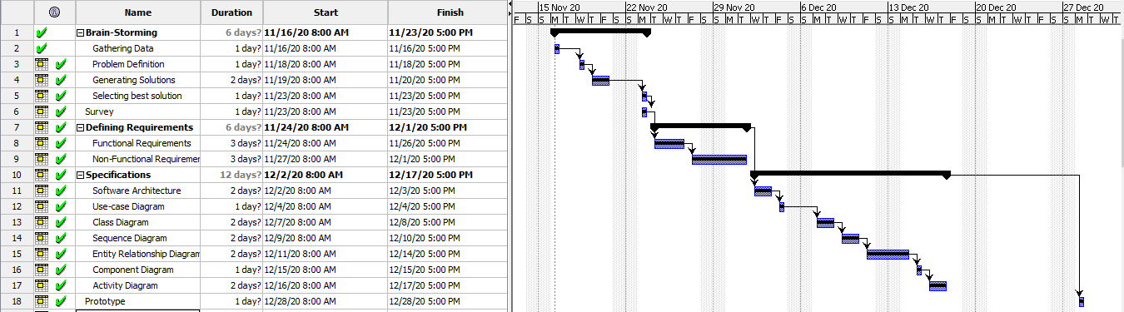***Gantt-Chart:***

